**The Catapult:**

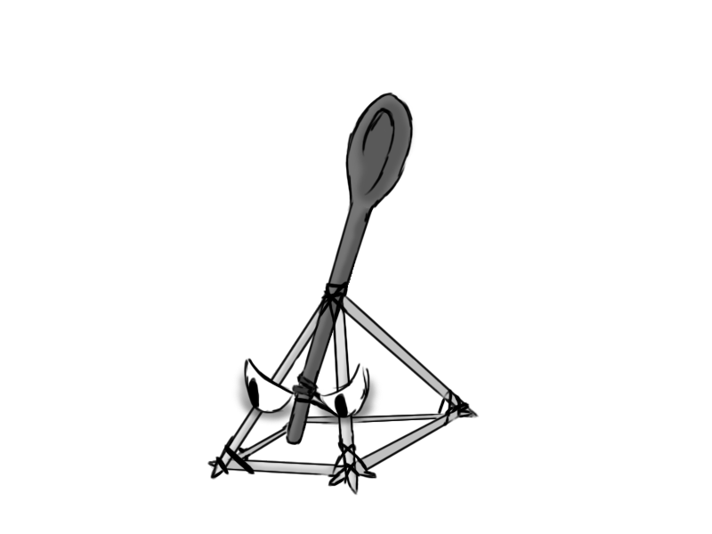

Figure 1 - Enemy: Catapult

**Brief Synopsis**

The Catapult is a static enemy that fires rocks from a distance. Each shot will display a crosshair on the floor 3 seconds before the fired rock lands. These enemies will essentially act as mortar fire and give the player motivation to continuously move around the area. As they are static and slow firing, they are lower priority then enemies they could be partnered with. That said, the rocks that they fire can become a serious threat if not taken care of.

**Variants.**

There will be no variants for the catapult, instead there is the possibility of varying the ammo type that is fired from them.

**AI**

The AI will simply try to find the player's position and fire a rock that is in that vicinity. These attacks can also damage the enemies so a tactic the player could use is to bait the catapult and the enemies at the same time and deal damage to a group of enemies without damaging themselves.

**Animations**

The catapult has three states, idle, death and attacking.

**Move:**

* Just stands there with no movement.

**Rotate:**

* Band gets pulled downwards with a rock loaded and then gets fired up into the air.

**Death:**

* Using Apex Destruction, it will self-destruct into chunks that will disappear.

**Average Size**

